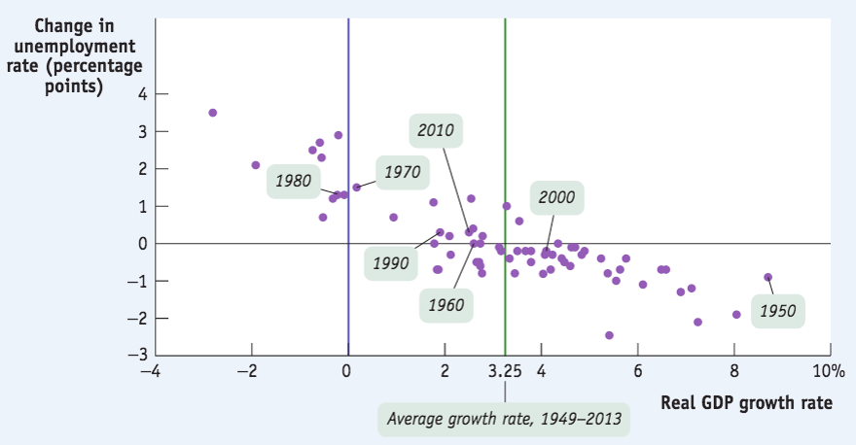

Look at the graph and describe which economic variables are represented.

a What does the [unemployment](https://moodle.unive.it/mod/resource/view.php?id=41013) rate represent?  
b What is the relationship between the two variables?  
c Is the [unemployment](https://moodle.unive.it/mod/resource/view.php?id=41013) rate a good indicator of the current state of the economy?

1. ***Unemployment rate:*** the percent of the total number of people in the labor force who are unemployed. The U.S. Census Bureau considers the unemployed those who are: “jobless, looking for jobs, and available for work”.
   * 1. Retired people don't 'count because they are not looking for jobs
     2. An individual is **considered unemployed if he or she does not currently have a job and has been actively seeking a job during the past four weeks**
2. **Lower growth is usually correlated with higher unemployment for two reasons:**
   * 1. ***When GDP falls, firms lay off workers.***
     2. ***Idle labor and capital → economic growth not being maximized → ↓ ability of the economy to create more jobs.***
3. It is not a perfect indicator because economists also take into consideration other things, such as the proportion of labor force in comparison with total population, or how the jobs are fitted for the workers ability, or the number of full-time jobs. All these things are not taken into consideration if you simply study the unemployment rate. Also there is frictional unemployment, which means that even in a healthy economy there is some unemployment because it takes time to find a job.

---------------------x---------------------------------------x---------------------------------------x-----------------------------------